**Objectives:**

The objective of this task is to introduce the fundamental SQL commands for database management by creating and manipulating tables within a database. Specifically, the task involves creating a database, defining tables for students and teachers, and performing various alterations such as adding columns, modifying column types, dropping columns, and renaming columns and tables. These operations aim to familiarize users with essential SQL syntax and procedures required to manage database structures effectively. Additionally, the task includes dropping tables and the database itself, demonstrating the full lifecycle of database management. This hands-on approach ensures a comprehensive understanding of basic DBMS operations for beginners.

**Lab 1: Data Definition Language (DDL)**

**Theory:**

Data Definition Language (DDL) is a subset of SQL (Structured Query Language) responsible for defining and managing the structure of databases and their objects. DDL commands enable you to create, modify, and delete database objects like tables, indexes, constraints, and more. Commonly used DDL in SQL querying are CREATE, ALTER, DROP, and TRUNCATE.

**Questions:**

1. **Create a database dbms1_yourname:**

**Query:**

CREATE DATABASE dbms1_sulav;

**Output:**

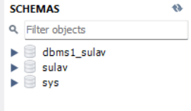

1. **Create table:**
2. **Student** (sid(int), name, gender, program)

**Query:**

USE dbms1_sulav;

CREATE TABLE Student (

sid INT NOT NULL,

name VARCHAR(100),

gender CHAR(1),

program VARCHAR(100));

**Output:**

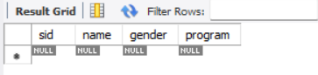

1. **Teacher** (id(int), name, address):

**Query:**

USE dbms1_sulav;

CREATE TABLE Teacher (

id INT NOT NULL,

name VARCHAR(100),

address VARCHAR(255)

);

**Output:**

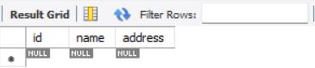

1. **Alter student table to add contactno:**

**Query:**

ALTER TABLE `dbms1_sulav`.`student` ADD COLUMN `contactno` VARCHAR(20) NULL;

**Output:**

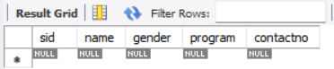

1. **Alter teacher table to add subject:**

**Query:**

ALTER TABLE `sulavdbms1`.`teacher` ADD COLUMN `subject` VARCHAR(50) NULL;

**Output:**

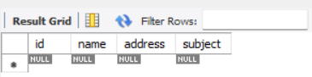

1. **Alter student table to change contactno to int**

**Query:**

ALTER TABLE `sulavdbms1`.`student` CHANGE COLUMN `contactno` `contactno` INT NULL;

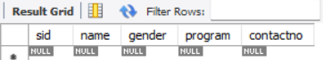**Output:**

1. **Alter teacher table to change address to int**

**Query:**

ALTER TABLE `sulavdbms1`.`teacher` CHANGE COLUMN `address` `address` INT NULL;

**Output:**

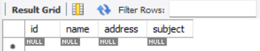

1. **Drop column gender from student table:**

**Query:**

ALTER TABLE `dbms1_sulav`.`Student` DROP COLUMN `gender`;

**Output:**

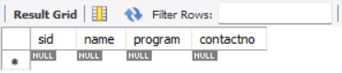

1. **Drop column address from teacher table:**

**Query:**

ALTER TABLE `dbms1_sulav`.`Teacher` DROP COLUMN `address`;

**Output:**

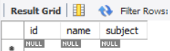

1. **Change student table column name to Sname**

**Query:**

ALTER TABLE `dbms1`.`Student` CHANGE COLUMN `name` `Sname` VARCHAR(45);

**Output:**

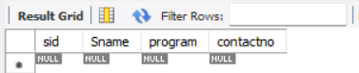

1. **Alter teacher table to rename id to tid:**

**Query:**

ALTER TABLE `dbms1_sulav`.`Teacher` CHANGE COLUMN `id` `tid` INT NOT NULL;

**Output:**

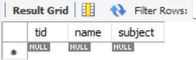

1. **Drop table teacher:**

**Query:**

DROP TABLE `dbms1_sulav`.`Teacher`;

**Output:**

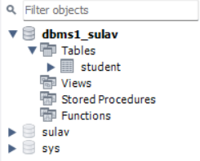

1. **Drop database sulavsulavdbms1:**

**Query:**

DROP DATABASE `dbms1_sulav`;

**Output:**

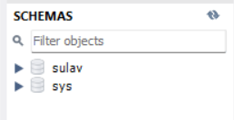

**Conclusion:**This exercise marks our first exploration into database management systems (DBMS), focusing on creating and manipulating a database and its tables. We successfully demonstrated the creation of a database and tables, along with altering the structure of tables by adding, modifying, and dropping columns. Additionally, we covered renaming columns and tables, as well as the deletion of tables and the database itself. This hands-on experience provides a solid foundation in SQL, enabling users to manage and manipulate database structures confidently. Overall, the exercise offers a practical introduction to essential DBMS operations, ensuring a robust understanding of basic SQL commands.